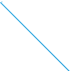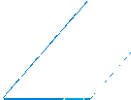





"#$ % & ' (()( *+ ' , - ./ )(0 1 2 334 5 0 6 7 $ 8 + & 9' :- ; 6 , < .)(- .' - & 0 :"= 0 >- & #- 7 ?.0 = - @ ' - :6 A B CD ECFG H H E I)& $ B 3D D EG J H H K $ 6 G , - ' & B L- ; ' 1 )9)M7 )N)1 (?.' - $ ; - $ 7 )N$ ; .

! " ! ! "

# $ %& $& # # # ' & " $ # ! (

) * + , - ! " , # . / 01 234563/ 7 8 :;<=> ? @ A B:CD ;<= > @ E D F@ G HI =J K =;L MD ;N@; : OB=<=P :> <@;Q ? @ R J => @ ? : STU@ ? @ V W NJ :@

? : R B@<:TU@ ? : X =? @;Y

" # # - Z # # # # & 8 [ & #

# Z $ # # $ #

\ " $ # 8 Z # # # & #

# ] ' & # $ # & # % 1

^ _ Z $& # # # $ Z # `

# ' & 8 8 & 8

+ 8 % ' & $ Z $& # # &

1

) # # Z # 1 a.8 bc , -! " d

fghh i jklmnojpq rk pstmunq v tjqnkwxq rk rmrqy tkyyqmpyz rqu{sk|nmwxq rq uq|njqlmrqj }{k uq|n~s m rkyujpwxq rqy tjqukyyqy rk njmnmsk|nq rk rmrqy tkyyqmpy }{k tqrks kjmj jpyuqy vy lp kjrmrky up py k mqy rpjkpnqy {|rmsk|nmpy ks uqsq skrprmy yml m {mjrmy k skum|pysqy rk spnp mwxq rk jpyuq

8 # ]% $ ( # 1 07 $ , 8



Z ] # d

jn m{nqjprmrk |mupq|ml tqrkj rknkjsp|mj mq uq|njqlmrqj

}{k klm qjk jklmnojpq rk pstmunq v tjqnkwxq rk rmrqy tkyyqmpy p|ul{yp k rk rmrqy yk|y kpy jk kjk|nk m y{my qtkjmw ky rk

!

"#$%#& ' & ( $#$ ) ' &' $ ' $ $* &+ ,%&-., ' , /0 1 2 3 & 4 $* 5 ,% ' $ #%) -., $( #,( 6%&7 $ ( ,

89 ) & ' $ : ,& 1 %;6) #& ' & < 81 2 3 ' ) = ,( ) + ) * ) >&' , = $* , 8,?$%( , @ $' $%&* A B

"* C4 ' , #& , $ = $#DE) #, = %$?) 6, = $* & < 81 2 F! ! ! G3 C ) ( ' ) #&' & & $* &+ ,%&-., ,9 &69 &* ) >&-., ' , /$* &6H%) , ' $ 0 4 = &#6, JKL M NK O P K KQR JSR N T M UJJR V R W R X TX K X K UYUNNKN R L M TYSU Z T M NR [TYR X TX K X UJ X TX UJ M KJJUTR J3 %$ 9 * 6&( 6$ ' $B 9 4 & 6$#( ,* ,\) &3 $%?) -, ,9 ,9 6%& ( ,?& ) ( ) #) &6) ?& KL O P K X TX UJ M KJJUTR J K X TX UJ M KJJUTR J JKZ J][KR J JK^TL UP X K[TL JKN SNTSTX UJ_ %& 6%$&4 $( 6, ' & * ,#&* ) >&-., ' , ) ( ' ) ?D' 9 , ,9

`9 &* `9 $% ,9 6%& &-., ' $ 6%&6&4 $( 6, `9 $ ?) $ & E,%4 &-., ' $ = $%E) * #,4 = ,%6&4 $( 6&* ' $ = $ ,& ( &69 %&* 3 $ ) ' $( 6) E) #&' &_ F< 81 2 3 &%6! A a b acG_ 6%&6&4 $( 6, ' $ ' &' , = $ ,&* ,+ %$ d UNR e KL NTYR TW UP fSZ R YTg YUZ [R YhiU NKW R e R UJTg UM R Z R iU M UW ]SR YTg jR W R ThiU T JR Z X R YTSU UP T UNe TZ R kThiU X K YTNlSKN NKW R e R UJUg jR W UJmjR YU UP M UW ]SR YUg X TX U NKjKNKZ SK n JTo X K UP n [R X T JKQP TW g X TX U e KZ fSR YU UP V R UL fSNR YUg O P TZ X U [R Z YP W TX U T P L T M KJJUT

Z TSP NTW p F< 81 2 3 &%6! qc3 0 0 G_ = %,#$ &4 $( 6, ' $ ' &' , = $ ,&) 9 &' , = &%& 6,4 &% ' $#) r$ &9 6,4 &6) >&' & `9 $ = , &4 6$%

$E$) 6, * $\&) 3 ) ( #* 9 D' & & ' $#) r$ ' $ 6) ( &' & & ' $E) ( ) % , $9



= $%E) * = $ ,&* 3 = %,E) ) ,( &* 3 ' $ #,( 9 4 , $ ' $ #%C' ) 6, ,9 , & = $#6, ' $ 9 & = $% ,( &* ) ' &' $ F< 81 2 3 &%6! asG_ 6%&6&4 $( 6, ' $

u vwxyz{w |y}yz~ v ~ }y w~ z ~ y vyz~ }y zw y w }y }~}w v }

} ~

 !

" # $ % & ' (& ' )

) ' * ' * + & & + &

* , & + + - ' . ! " #

/ 0 1 # 23/ % 4 5% # 6

7 8 / 3 1 # 3 # / 5% # 6 9 % 4

# 4 5 6: : # 1 6; # <

= >< ! ' (? '

@ = >< ! / 6; # / 5% / " #

/ 3A4 B 4 3 / C 3 # " # # 6:

" # 1 " 6; D "

1/ % 2 # 4 % / 3 ! 1 "

" # 4 $ % " / 3 " " # 4 % % 5 # 0 3 # /

% / # # 3 6: 1% : % 3 : D 5: %

#

E # 3 # # $ % 1 # 7 8 / 3 9 F G

" # 3 " # C4 #

$ % # 1 # H 4 " 3 / 8 3 " 1 " " % " B / $ % 6: I # % 6: B / 6: 1 0J # 3 A / 8 6: K / D I " 3 B 6:

" # " / 6: 3 " 3 C 3

" 4 # 3% " # / 8 / E 7 3/ 6:

1 # 7 8 / 3 9 F G 3 " 8 # % F

A 3 % 4 # L / 4 2 / 3 # 3

 1 " # 6: 1 # 3 # G 3 " # 5 4 1 " / 0 6: I # % 6:

N O P Q OR STOUVS N S TP Q OWXTY S N P Y Z [O\WS

] KI / 8 " 4 # 3 $ % 6: % " I # % 6: B ^ # # 3 " # # 1

`ab c d e ffgf h i e j k lm gfn o p qqr s n t u b v i d we xk y t j z lgfk le k d n x`{ n |k d ak u }ln { k ~ e k xt

gd b q b t j k e d k y e o gwg u g go f}le k b y k b u g b y l



!

" # $

% &

' (

)

"

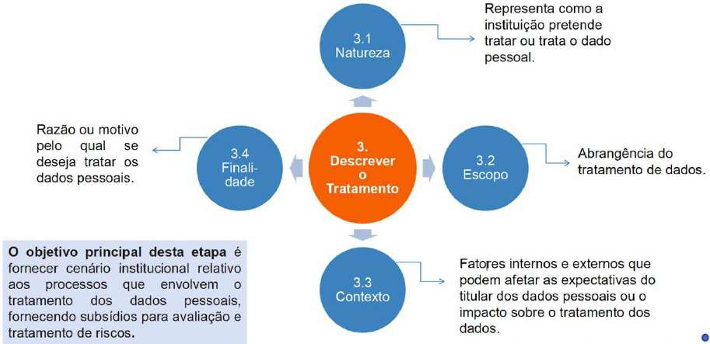

+,-./0 1 2 3456/,789 :9 ;/0<0=4><9 ?@ -9A@ B/C

D E #

$

F

G " "

H&

I

G )



! & E

K L MNO PQ RSTU V WX YX PR Z[\]X ^TSRTR_`aTQb cQadTeTNe TQPR Qf`SRghQ S`RMeORPR cQ_ PRPQd f`ddQRedX cQ_Q Rd iN` d` S`j`S`_ R cQM`TRX fSQPNghQX S`c`fghQX cMRddejecRghQX NTeMeORghQX Rc`ddQX S`fSQPNghQX TSRad_eddhQX PedTSekNeghQX fSQc`ddR_`aTQX RSiNelR_`aTQX RS_RO`aR_`aTQX `Me_eaRghQX RlRMeRghQ QN cQaTSQM` PR eajQS_RghQX _QPejecRghQX cQ_NaecRghQX TSRadj`SmaceRX PejNdhQ QN `nTSRghQU

pqr s t u vvwv x y u z { |} wv~ ~ r y t u { z |wv{ |u { t ~ p ~ { t q{ |~ { u {

wt r r z { u t { u w w w w v |u { r { r w r |

!"#$%&'(" !" #"'()"*+!") ,$& #"'(-% +

!&.#)/01" !". 2)"#&..". !& ()+(+%&'(" !& !+!". 2&.."+/. ,$& 2"!&% 3&)+) )/.#".

4. */5&)!+!&. #/6/. & +". !/)&/(". 7$'!+%&'(+/.8 ,$& 2)&6&&% %&!/!+.8 .+*6+3$+)!+. & %&#+'/.%". !& %/(/3+01" !& )/.#"8 9

: ; < =

> ?

@ =

; > A =

B C A

=

D A =

A E

> = F G H I KL MK N KOP QRSK TU OQKOKVRW OU

: X =

9

= Y X Z F 9I ; [ 9 > G Z ; >

; \ =

= ; Z = X

 F = ; = G

=

@

A = ? A

= ; >

! "#$ #%%! &!%#$ %' ( ! ' " !) ! ! ' ' ! " ' # !*+ ! ,( )! -' # "# % # % &( ' . % "# "!" % "! % ' *+ /

1 2 34 567484 94 :;<:<= 5> :42

? !@ ! ) A ! " ! ! # B C D D E D FG

H I J

D J K H E L D H J

I FH E D FH D H D D B M D

E D NL O N N OE D B

? D E D FG D K D

D P D K B

72 34 Q4> :5R:4 94 :;<:<= 5> :4

S FH K D PD D O D D

E K D E K

D D B ? D

N E D FG K FH TD

D H D I

D U

V D N FH D

I J

V I DP I K D

 J

V D F

N O J

V D P



! " # ! $ % &' & ( $" &%

) * + , -

. * / + ,1 234 54 67 8 39737: ;< 38 * * = / +

>

/ ?@ A A @ B C D E / F

G H I

+ G

, /

G H , /

*H

/ I

E J / * *

H +

K * K / E / >

* / + L M

L M L M L M /

*H G /



OPQ R S T UUVU W X T Y Z [\VU] ^ _ ``a b ] c d Q e X S fT g Z h c Y i [VUZ [T Z S ] g Oj ] kZ S PZ d l[] j Z m T Z gc n o pq rpst u u r vVS Q o `q q rt w u u x Q c t Y Z T S o yZ h T ^ VfVzd V{V^ Ul[T Z Q h Z Q d V{Q h [

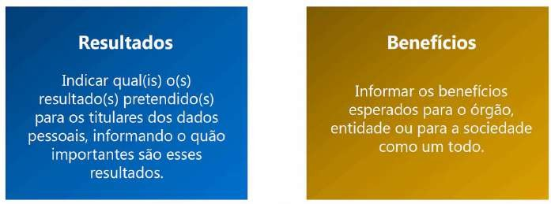

!" #" $ %&' ( ) *! ( " ! * (( ( $' (+ , ! (

. /012 /1232 42 /5 267829:7 47 ;/5 21<8= 7 4 / > ? 32@17A = ? 37812 = 4 /B 1= C= @28 20 3281/0

= B 1/8/002420 8/5 /D2B 1/0A = B 1/8B 20 / /E1/8B 20A @7B 0F 5 12420 2 C= ? 4 / 761/8 73 = B = G/0 5 /H 2= 0A 1I@B = @20 7F 24 ? = B = 01821= D20 0768/ 70 42470 3 /0072= 0 JF / 0:7 76 K/17 47

18212?/B 17L M00= ? A I = ? 37812B 1/ 2 = 4 /B 1= C= @29:7 4 / JF 2= 0 3281/0 C782? @7B 0F 5 12420A

6 /? @7? 7 7 JF / @242 3281/ @7B 0F 5 1242 = B 4 = @7F @7? 7 = ? 37812B 1/ 4 / 0/8 760/8D247

3282 7 18212?/B 17 470 42470 3 /0072= 0 /? 8/5 29:7 270 3700ND/= 0 8= 0@70 8/C/8/B 1/0 O0

21= D= 424 /0 4 / 18212?/B 17 /? 2B P5 = 0/L

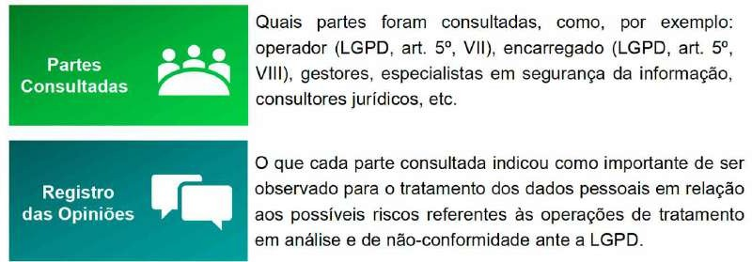

Q R S

T2? 6 I? 4 /D/U0/ 760/8D28 70 8= 0@70 4 / B :7U@7B C78? = 424 / 2B 1/ 2 VWXY / 70

= B 018F ?/B 170 = B 1/8B 70 4 / @7B 1875 / Z 375 N 1= @20A 387@/0070 / 387@/4 = ?/B 170 D75 12470 O 3871/9:7 4 / 42470 / 38= D2@= 424 /[ L

\207 B :7 0/K2 @7B D/B = /B 1/ 8/H= 01828 7 JF / C7= @7B 0F 5 1247A /B 1:7 I = ? 37812B 1/ 238/0/B 128 7 ? 71= D7 4 / B :7 1/8 8/25 = ]247 125 8/H= 0187L \7? 7A 378 /E/? 3 5 7A 238/0/B 128

KF 01= C= @21= D2 4 / JF / = B C78? 28 7 8/H= 0187 420 73 = B = G/0 420 3281/0 = B 1/8B 20

@7? 387?/1/8= 2 0/H 8/47 @7?/8@= 25 7F = B 4 F 018= 25 ^ C82H= 5 = ]28= 2 2 0/HF 82B 92 42

!"#$ %&' ( " !!$ )#')'#"$ '( * $

+ ,- ./ 0

1 2

3

0 4 0

5 6 789 ./ 0 :;0 - - - <

+ 0 0 =

0 2 2 7 5 0 0

> < 2

2

89 ./ = 789 ./ 0 ?;0 1- <

@ 0 A 3

789 ./ 0 B C< 0 D E 0 F

2 5

E A / F 0

2

B G 89 ./

H $ ( I$ $ " %&' J * $ %&' '! #$ !"'!

K ?;0 L1- - 89 ./ 2 , E - M 0 M @ F 0

 0 = 2

. 0 F N

4 0 3

0 3

. 0 9 O . @ 2 6 89 ./

! " $%& '()* )*+, - . & %/ '* - %(% 0& %**, 1, 0%23' / '* (, 0'* / )

%0'(/ ' 0'4 ' 5 (%. 67 %, 8'9 4 '/ )(%/ ' '. %& +': / ) - ('7 %7 , & , / %/ ) / ) *. %

'0'((;< 0, % ) / ) , 4 - %0+' 5 )(%/ '9 0%*' '0'((% =

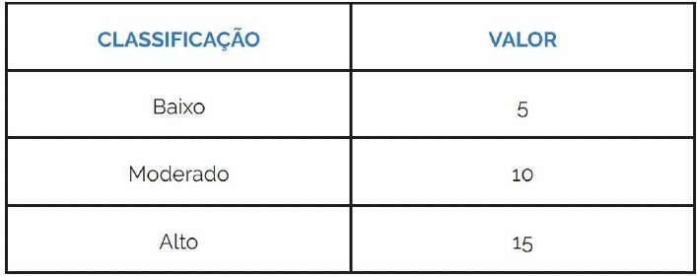

?@ABC@ D E@FGHBIFJK LKM@C@FBK NO PJQO AFR

! S %+(, T U ('7 %7 , & , / %/ ) 8 V 4 - %0+'9 ()*. & +%< +) / '

- ('/ . +' )< +() '* $%& '()* %+(, 7 . W/ '*9

X

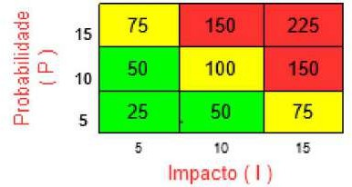

YZP[F@ \ ]@IFZ^ EFJA@AZCZ_@_B ` aHb@MIJ

d efghijf khlhimno epqm lh rfms tiuvqwms nhq ehimn lh tifvhxyf lh lmlfs znetl{o l|}~ o m }}

! ! " # $% & '

( ) * & + , -

( " ) ! & -

( " . ) & & " %

/ ) * ! & 0 1 1 " &

! " . & 2 " 3 & 4 5 & 6 ! & ! " 7 8 9 : ; < 2 =:4>

? @ ) @ A BA@ C $%

/ & & D 9 ) " 8 & & ! &

! D & 8 E" & " ! & " & &

+ ; 8 ! ! ! & %

! & D & 8 " 8 & " 1 F 1

G G 1 HF % 2 ) "

& ! & + 7 I =7 J : BK@ L$' BA@ M) 8 C% $% $) &

! " 4 # " ) ! ; 3 & ! &

8 D 8 " & & ! 8 ! ) & D

+ " + , '

|  |  |  |  |  |
| --- | --- | --- | --- | --- |
| 7 / | 57 I: 5J # J 5J 9 NJ O N5ONO< J 9 N / J / O/ I 2 J II O7 I | 2 | 7 | 9 PQJ R / J  57 I: S2 ,7 T |
| 5A@ | O& |  |  |  |
| 5AB | < D & 8 |  |  |  |
| 5AL | 2 |  |  |  |
| 5A$ | 5 + |  |  |  |

V WXYZ [\ ]^X^ _`ab cdbY^ eabYXfgh\ i\Xj^Y`k^l m\ab`cdX^nbdo pZ Z Z q ree n sdXdam`^jdaY\ cd X`bm\bo tX\mdbb\ t^X^



`cdaY`_`m^Xl ^k^u`^Xl ^cj`a`bYX^X d m\aYX\u^X t\Ydam`^`b dkdaY\b \f b`Yf^gvdbl t^X^ _\XadmdX X^w\xkdu mdXYdw^ yf^aY\

^\ ^um^amd c\b \z{dY`k\b c^ \Xs^a`w^gh\| pZ Z Z q }eee n X`bm\o t\bb`z`u`c^cd cd \m\XX~am`^ cd fj dkdaY\ yfd kda ^ ^ YdX `jt^mY\ a\ mfjtX`jdaY\ c\b \z{dY`k\bZ X`bm\ jdc`c\ dj YdXj\b cd `jt^mY\ d cd tX\z^z`u`c^cd| }er n X`bm\ `adXdaYdo X`bm\ ^ yfd fj^ \Xs^a`w^gh\ dbYx d t\bY^ bdj m\ab`cdX^X yf^`byfdX ^gvdb sdXdam`^`b yfd t\bb^j Xdcfw`X ^ tX\z^z`u`c^cd cd bf^ \m\XX~am`^ \f bdf `jt^mY\| }r n X`bm\ Xdb`cf^uo X`bm\ ^ yfd fj^ \Xs^a`w^gh\ dbYx d t\bY^ ^t b ^ `jtudjdaY^gh\ cd ^gvdb sdXdam`^`b t^X^ \ YX^Y^jdaY\ c\ X`bm\Z

|  |  |  |  |  |
| --- | --- | --- | --- | --- |
|  |  |  |  |  |
|  |  |  |  |  |
|  |  |  |  |  |
|  | ! ! " # |  |  |  |
| $ | % & ' # (  " # |  |  |  |
| ) | &  *  # |  |  |  |
| ) ) | ! # |  |  |  |
| ) + | , - -  # |  |  |  |
|  | . |  |  |  |

012341 5 6 789:;9 <3=3<3>?39 1; ?<1?1@3>?; A3 A1A;9 B399;189

C ! ( D E D F E #

) # D ( & ! - -

- G G F H !

I J.K ' L) ( + $- +# ) $" #

+# ( G J.K ' L) ( + $- +# ) " #

L# M N ( ! -

G O J.K ' L) ( + $- +# +L M JPQKR ' S ) - + ) $- # +S- T " #

V W XY Z [\] ^Z _Z `Yabc [\ d\[ Z [ Ye f YgY ^gY^Yg ce gZ e`ce

J H G ! ! -

h !

i N - - -

G G G N CPDQ- # j " #

! " #

$ # % &

"

$ '

(

*+*,-. /0 1 * ,*12 130

& ( 4 !

$ 5

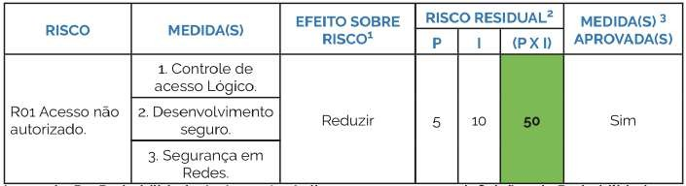

6 5 7 % 7 & & 8 % # ' 7 & &

9 : 7 ;

< = &

' 5 >*1 ? @2 AB CD2 E3AB F/,- 3AE2 . G 3A * HI*2 E3AJ

K : ! $# L = &

" $ & : 7 ;

&



&

! " #$ %& " ' ( ! "

( ) " ( * ' ! " #$ %& + ( , + ( , - " "

! " " " + . " ( " ,/ " + ' , , 0( , "

) " " 1 ) ( , ( " 2

3 ( * ' ! " # 4 " 4 ( , - " )

1 ) 1 ) ) " -( " , ( " , , ( / , ( ( , *

2 5 6

3 #$ %& " ) " ( ) ( ) 1 ) 7 1 ) 1 ) " ) " ( 1 ) ( " " " " ( ) ! 2 & ) - + ) " ( " " ! 8

9 -( , ( ( " " " ( " " " :

9 1 ) , ( , " , " " ! " :

9 7 ( 1 ) ( " " " " " , " :

9 ( , ( 7 " ( " " " ) ( " " ( , ! " / "

-) ( + ) " ) ( ,( - + ( ,) ! ; ' , ' "

( " " " " ( ) ! ) ) ( ' " " " ) - )

,< , " ) " " " 2

.) " , 1 ) ( = ( > " ( , ! " ( , " " "

' ) ) #$ %& , ( ( " ?2 @2 ?2 ? " " ,) ( ' A

, ( ') " ( , ! " , 1 ) # 4 " $ , "

 ) " 2 B ( ) ! " ( ! " #$ %& " " ( 1 )

, ( ( ) ( , " ( " " " 1 ) ) -

, ( 1 ) 0( , " " ( " ( = ( , ( * ,( 4- , + ( + < , ( ) , ( 2

! " # $ % & ' & $ $ $ $ ' ( & ) $ * + , # ( # $ #

" % -. $ #

# $ / 0& ' / 1 2 34 56782 9! 4

: ( " # $

< = > ? @= A BC DE F DGH I? GJ=G K LMDNDO K< N=GP Q = R E D< = Q K STU= Q = V W JE K=

Q K R M=NKTU= Q K X DQ =GH YZ " $ #

[ : $ & ' #

# # \ $ % $ # ' & * 8+ %

# # ( $ $ $ $ ( #

$ # / 0& ' ] # # - $ 4





! " # $ %&'( )*+ &$ *,-. $ &/ &01 2

,-3 '+ *1 *,-. $ + 4 3 ,5 2 6 3 + 7 ,/ + $ ,5 %&' 8 '+ 9)-1 + ( 8 )-* )55,55( ,$ * + 58 &$ :9,/ ,( ;

= >>?@A BBCD E F @>GE D GHD @F I >J= F GI B@GK ? L J@BMNNOPBQQR CGOMJD MOMSPTUR NOR VTND OUSW XW UW BY Z

[\Y ] ^\NPW XS\NTW QF ? D U -,55& ,( ; " ""!

6 _ ` 6 a b c d 6 c ef

g 6 c h + 58 &$ i9,/ ,( ;

= >>?@A BBjjjF klmF R HBklmJHE lD I kI >GL B? >\R HB? HI mGCI D GD J\J\@Jkn HGE CGBkn I G@Bkn I GoL k? D F ? D U

-,55& ,( ; "p " !

a ef q _ r a s t " q " u + 58 v, 5&w ',

-&$ *'&/ ,5 + $ *,'$ &5t 0,5*x& 7 , '+ 5-&5 , 0&9,'$ )$ y) $ & z( w + *& 7 & c &7 ,' {,-3 *+ 9&

%,7 ,')/ + 58 &$ i9,/ ,( ;

%+ / ,; ; a 5,'5 w '3 $ ) |3 -) &}$ / &)7 5 + $ 5*'3 -)&~$ &'( )*+ 9)~-&$ |3 $ *)~$ &~ ~7 ,~ "~7 ,~(

)+ &~7 , 8 7 % -,55& ,( ; " " !

